**AIM: Design a web page to demonstrate a connection oriented architecture & disconnected architecture.**

**DB Config:**

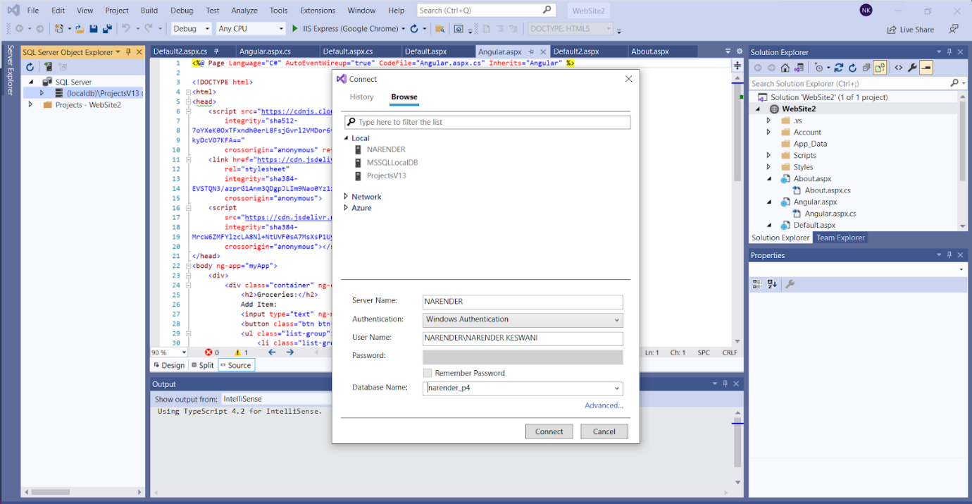

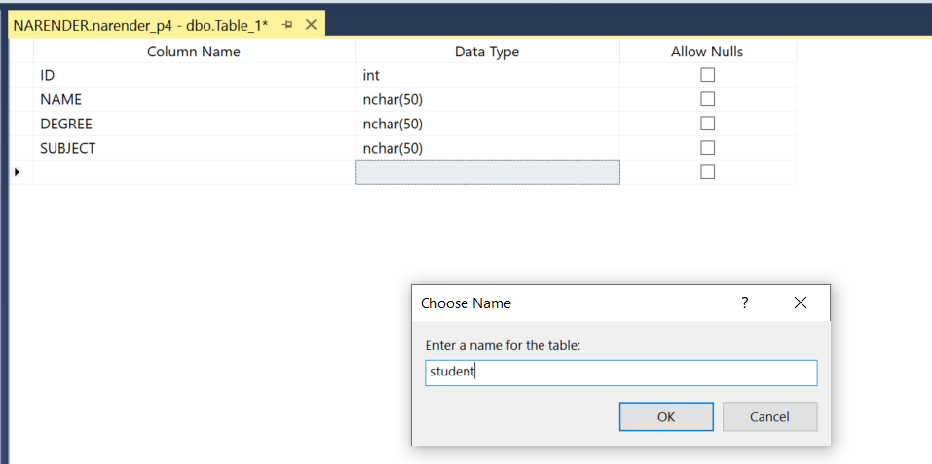

**WebConfig:**

<connectionStrings>

<add name="ApplicationServices" connectionString="server=. ; database=narender_p4; Trusted_Connection=Yes;" providerName="System.Data.SqlClient"/>

</connectionStrings>

1. **Design a web page to demonstrate a connection oriented architecture. Fetch Student details from database such as Roll_no, Name, Program(eg. MCA), Course(eg. AWT), etc.**

**SOURCE CODE:**

**ConnectedDb.aspx:**

<%@ Page Language="C#" AutoEventWireup="true" CodeFile="ConnectedDB.aspx.cs" Inherits="ConnectedDB" %>

<!DOCTYPE html>

<html xmlns="http://www.w3.org/1999/xhtml">

<head runat="server"></head>

<body>

<form id="form1" runat="server">

<div class="container">

<h2>Display Data using Connected Architecture</h2>

<asp:GridView ID="GridView1" runat="server"></asp:GridView>

</div>

</form>

</body>

</html>

**ConnectedDb.aspx.cs:**

using System;

using System.Collections.Generic;

using System.Linq;

using System.Web;

using System.Web.UI;

using System.Web.UI.WebControls;

using System.Data;

using System.Data.SqlClient;

using System.Configuration;

public partial class ConnectedDB : System.Web.UI.Page

{

protected void Page_Load(object sender, EventArgs e)

{

string connStr= ConfigurationManager.ConnectionStrings["ApplicationServices"].ConnectionString;

SqlConnection con = new SqlConnection(connStr);

{

SqlCommand query = new SqlCommand(" select * from student ", con);

con.Open();

SqlDataReader rdr = query.ExecuteReader();

GridView1.DataSource = rdr;

GridView1.DataBind();

}

}

}

**OUTPUT:**

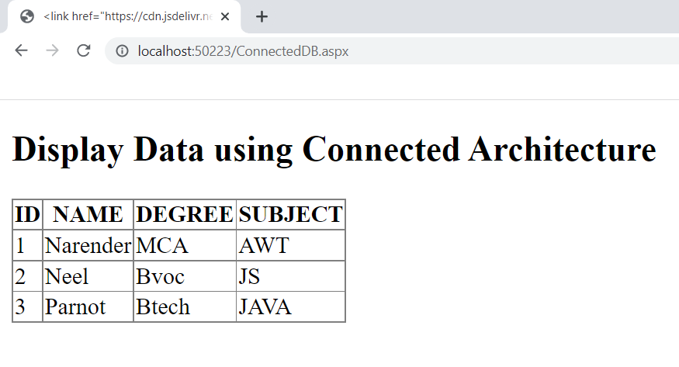

1. **Design a web page to demonstrate a disconnected architecture. Fetch Student details from database such as Roll_no, Name, Program(eg. MCA), Course(eg. AWT), etc.**

**SOURCE CODE:**

**UnConnectedDb.aspx:**

<%@ Page Language="C#" AutoEventWireup="true" CodeFile="UnConnectedDB.aspx.cs" Inherits="UnConnectedDB" %>

<!DOCTYPE html>

<html xmlns="http://www.w3.org/1999/xhtml">

<head runat="server">

</head>

<body>

<form id="form1" runat="server">

<div class="container">

<h2>Display Data using Disconnected Architecture</h2>

<asp:GridView ID="GridView1" runat="server"></asp:GridView>

</div>

</form>

</body>

</html>

**UnConnectedDb.aspx.cs:**

using System;

using System.Collections.Generic;

using System.Linq;

using System.Web;

using System.Web.UI;

using System.Web.UI.WebControls;

using System.Data;

using System.Data.SqlClient;

using System.Configuration;

public partial class UnConnectedDB : System.Web.UI.Page

{

protected void Page_Load(object sender, EventArgs e)

{

string connStr = ConfigurationManager.ConnectionStrings["ApplicationServices"].ConnectionString;

SqlConnection conn = new SqlConnection(connStr);

{

string query = "Select * from Student";

SqlDataAdapter da = new SqlDataAdapter(query, conn);

DataSet ds = new DataSet();

da.Fill(ds);

GridView1.DataSource = ds;

GridView1.DataBind();

}

}

}

**OUTPUT:**

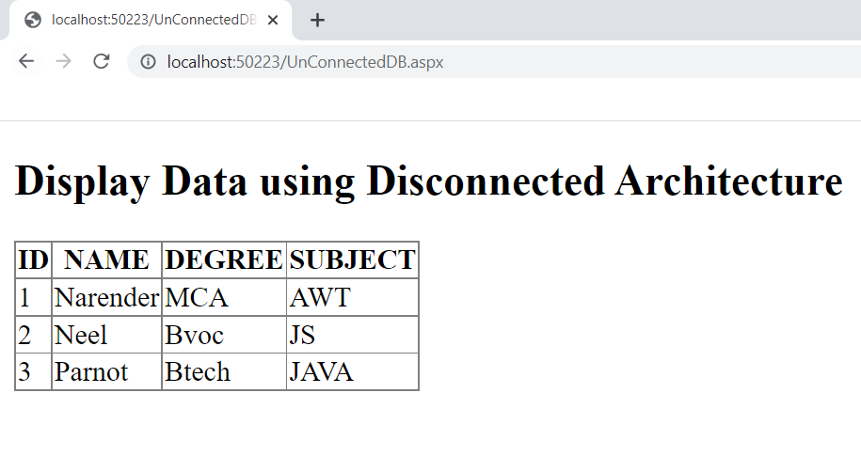

**CONCLUSION:**

From this practical, I have learned how to connect asp.net with database, also learned about connected and disconnected architecture.